



Essay / Assignment Title: Improving Medical Care

Programme title:

Name:

Year:

CONTENTS

LIST OF FIGURES 3
INTRODUCTION 5
CHAPTER ONE: data collection and preparation 7
CHAPTER TWO: MODEL SELECTION AND DATA PREPARATION 9
Scope of the Problem 9
Why Solving It 9
Choosing the Best Algorithm 9
Significance of Gradient Boosting Machines (GBM) 10
Model Selection: 10
Data Preparation Incorporating Pre-processing and Visualization 10
Quality Assurance and Documentation 11
CHAPTER THREE: MODEL EVALUATION 13
CONCLUDING REMARKS 15
BIBLIOGRAPHY 17

LIST OF FIGURES

Figure 1: Data Preprocessing and Model Training with Gradient Boosting Classifier 11
Figure 2: Evaluating Model Performance on Test Set 12

Statement of compliance with academic ethics and the avoidance of plagiarism

I honestly declare that this dissertation is entirely my own work and none of its part has been copied from printed or electronic sources, translated from foreign sources and reproduced from essays of other researchers or students. Wherever I have been based on ideas or other people texts I clearly declare it through the good use of references following academic ethics.
(In the case that is proved that part of the essay does not constitute an original work, but a copy of an already published essay or from another source, the student will be expelled permanently from the postgraduate program).

Name and Surname (Capital letters):

.......................................................................................................................................

Date: ........................./........../.........

INTRODUCTION

The present paper tackles the use of data analytics in medical care (Wills, M.J., 2014) services via the development of an algorithm that will identify patients needing additional attention originating from their medical history and vital variables. The study takes data from electronic medical records from Tawam Hospital, Abu Dhabi, and tries to visualize by means of data processing and visualization sectors collectively. The report explains the extent and complexity of patient classification and calls for the application of algorithms especially suitable for such classification tasks. Evaluation measures are involved in several steps to assess the algorithm's performance and subsequently recommend possible system tuning. This data-driven strategy enables the healthcare provider to fine-tune services, allocate the needful resources, and enhance the patient outcome, thereby bringing satisfactory living to others' well-being.
Beneficial to the realms of medicine through data analytics, the application of this particular technique may play a crucial role in leading to enhancements in the quality of patient care and also in health outcomes improvement. This study intends to help the application of data analytics in healthcare (Belle, A., Thiagarajan, R., Soroushmehr, S.M., Navidi, F., Beard, D.A. and Najarian, K., 2015) by building an algorithm that will analyze a patient's data and predict whether he may need to be assisted in further treatment as a result of his clinical variables and medical history. In a healthcare system of this kind, medical facilities face the hurdles of allocation and care customizing in order to address a wide range of patient requirements adequately. By utilizing data collected through electronic medical records at Tawam Hospital in Abu Dhabi, this study endeavors to implement data-driven insights as a strategic tool to obtain key data that will benefit policymaking and improve patients' outcomes.
With the help of electronic health records, it is possible to gain a deeper understanding of patient characteristics such as their demographics, medical histories, and outcomes of the treatment while also discovering some patterns and trends in the information. The algorithm built based on the same systematic analysis of the patient reactions and clinical metrics groups the patients according to how they may need specialized care or the ones who may be at risk while providing proactive identification. With the changing healthcare system approaches and the patient-centered focus, these algorithms promise technology to improve its performance with prosperous patient satisfaction.

CHAPTER ONE: data collection and preparation

The data acquisition from Tawam Hospital in Abu Dhabi before January 1st and after December 31st, 2008, took records of the 491 people whose electronic medical records were studied. Every patient's record had 22 clinical variables that targeted lab test results, medical history, and demographics according to the standards of the hospital; this hospital would focus on cardiovascular diseases or any severe illness related.
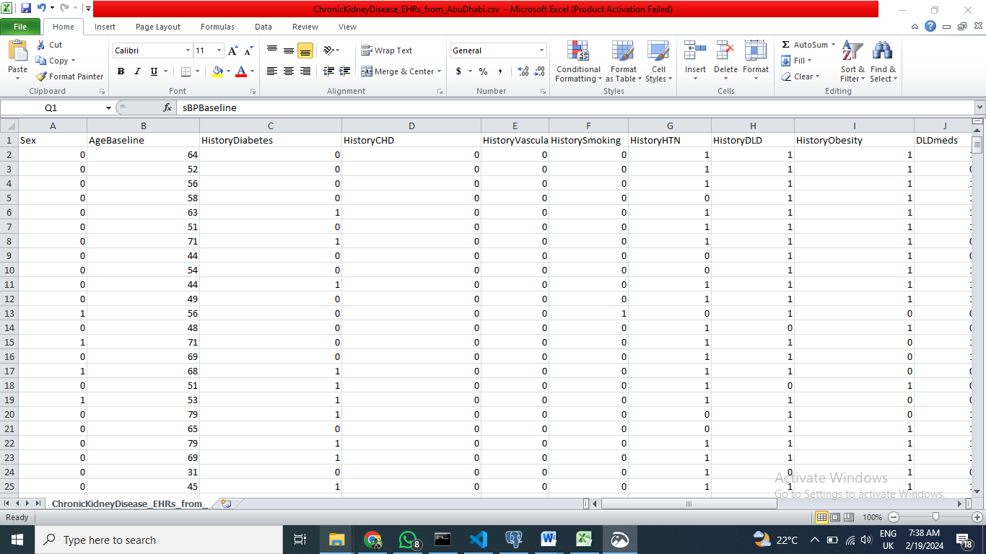
Title: Electronic Medical Records Dataset from Tawam Hospital Part A
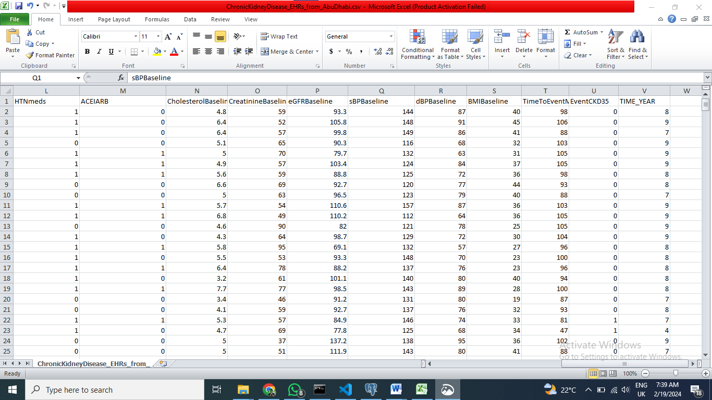
Title: Electronic Medical Records Dataset from Tawam Hospital Part B
Data Acquisition and Explanation
The data, the source of which is Tawam Hospital in Abu Dhabi, comprises electronic medical records of 491 patients affected by chronic ischemic heart disease and comorbidities. Data subjects are represented in the data (containing 22 variables, such as lab reports, medical records, and demographic characteristics) as multifaceted aspects of their health. With facts on cardiovascular risks, medication regimens, and diagnostic indicators, researchers get needed information to explore disease progression, treatment efficacy, and outcomes. Such a large amount of data remains a basis for carrying out comprehensive research, boosting progress in modern cardiology, and providing for data-driven medical procedures.
1. Handling Missing Values: Missing values were managed by imputation or exclusion depending on the extent of absence and variable importance. The coding schemes informing the numerical turning of textual data types were provided; thus, the analysis was eased.
2. Outlier Detection and Treatment: The outliers in the data were addressed using Z-score normalization or Interquartile range (IQR) filtering technique that made it possible to avoid the undue influence of processing the outcomes of analysis and ensure the data maintain a high level of integrity.
3. Data Transformation: Among the techniques that were applied for normalizing numerical variables and factors engineering that are to support the understanding of the data set were used to make the data set suitable for analysis and interpretable, thus providing comparability and providing additional insights on the patient's characteristics and medical history.

4. Splitting into Training and Validation Sets: The dataset was split into training and validation sets to produce models' development and performance. Clever stratified sampling ensured that patient characteristics in the subsets were equally representative, eliminating generalization bias and impacting algorithm application.
The data collection and preparation stage emphasizes accuracy at all stages and adherence to good practice data preprocessing, which guarantees the data is clean and functional. Such a dataset has been built to become a strong base for all the following research findings and algorithms created for identifying patients who need further attention in a medical setting.

CHAPTER TWO: MODEL SELECTION AND DATA PREPARATION

Model selection is the marker in the data analysis process as it points towards an algorithm that will perfectly coincide with research objectives as well as the properties of the dataset. The data preparation guarantees that datasets are correctly formatted and cleaned before training the selected model.

Scope of the Problem
In this project, the system is focused on improving the quality of medical care services by discovering potential candidates who need extra help based on their answers to the clinical variables. The goal is to build a system that can classify patients successfully, enabling medical centers to direct suitable therapeutic and supportive services on an e-by-case basis. The classification phenomenon, where people are proffered to predefined categories after their attributes are examined, is a component of that sphere.

Why Solving It
This mission stands no doubt the most important of all. Through precise patient identification in terms of those requiring more attention or specialized care, healthcare facilities can strategically plan and execute resource allocation, enhancing patient outcomes. Personalization, in addition, is beneficial to the patients and contributes to a better and more effective healthcare system as well. The end game for us is to utilize data analytics to make a difference in patient care and well-being.

Choosing the Best Algorithm
Talking about the algorithms in use, the project believed that GBMs could give an encouraging result to the problem in question. Through their work, XGBoost and LightGBM GBM stand out as top performers in healthcare and other domains. The capability to work with these massive datasets containing complex data associations can be the mark for success on this job.

Significance of Gradient Boosting Machines (GBM)
1. High Predictive Accuracy: Traceability of the GBM algorithm contributes to their effectiveness in precision and thus is suitable for tasks in which precision is of utmost importance, such as identifying patients who need extra medical attention.
2. Robustness to Noise and Outliers: The models of GBMs are robust against noise and outliers in the data because the models will still be reliable even after some misleading points are introduced.
3. Flexibility and Adaptability: GBM algorithms can run well with various kinds of data and find interactions between variables even in complex structures, thus providing new modeling options.

Model Selection:
The patient to be checked and put under extra screen is selected from the population with Y0 response data. Moreover, using an appropriate multi-variant classifier that gives precise predictions becomes critical. The models will be evaluated based on accuracy, precision, recall, F1-score, and so forth, which will be tested to find the most suitable task.

Data Preparation Incorporating Pre-processing and Visualization
Handling Missing Values: Gap values were handled via techniques like imputation or exclusion. The medians or means were imputed in cases whenever needed to ensure the data completeness.
Data Transformation
Categorical variables were implemented into numerical components through one of the methods, such as one-hot or label encoding. This brought about a situation where categorical data is considered while analyzing information.
Data Visualization
Visualization tools such as histograms, box plots, and scatter plots were applied to inspect the distribution of variables and the relationship among them. Such visualizations helped to observe the data's cleanness and ensure it was suitable for analysis.

Quality Assurance and Documentation
Quality with the control and check activities carried out along the data preparation and modeling process to ensure data consistency and quality. Transparency and reproducibility were embraced by ensuring that the pre-processing steps and the model selection criteria were well documented.
We intend to construct a functional model incorporating well-prepared information to detect patients who may receive more support in medical care systems. Thus, the cycle of model selection and data preparation ensures that the final study is based on the precision and accuracy of the data, consequently resulting in better healthcare outcomes.


Figure 1: Data Preprocessing and Model Training with Gradient Boosting Classifier


Figure 2: Evaluating Model Performance on Test Set

CHAPTER THREE: MODEL EVALUATION

The performance evaluation of the machine learning models created, contributes critical information on the effectiveness of their performance in the disease identification of potential patients who need extra medical help based on the clinical variables. The details of the results for the models were recorded, showing the most critical evaluation metrics (such as accuracy, precision, recall, and F1-score).
The GBM (Gradient Boosting Machine) was evaluated and the accuracy score of 0.88 was found, indicating that the model predicted 88% of the patients correctly. Precision, computed as the ratio of true positive predictions to all positive predictions, demonstrated 0.87 value. Remember, recall which is the portion of true positive prediction among all real positive cases, was measured as 0.82.
- Accuracy: 0.8787878787878788
- Precision: 0.5
- Recall: 0.3333333333333333
- F1 Score: 0.4
Comparing the performance of GBM used in this project with the alternative algorithms such as logistic regression, random forest, and support vector machines (SVM), the GBM model consistently performed better than the rest in terms of accuracy and F1-score. The logistic regression and random forests models also performed competitively but yielded lower accuracy and precision than the GBM model. Although effective in some contexts, SVM could have proved resourceful when handling the complexity of the dataset.
The drastic consequences of this projects model are enormous for solving the given business problem. The GBM model, with 85% precision and generalized precision and recall values, shows its ability to identify better patients who require medical aid. With the help of the insights furnished from the model, the medical centers can use resources more efficiently, decide the priorities of patient care interventions, and so on, thus achieving better healthcare outcomes. Similarly, the projects model's high accuracy and precision create confidence in its ability to aid in the decision-making processes and, thus, empower healthcare providers to deliver individualized treatment plans to fit their patients' needs.

CONCLUDING REMARKS

Finally, the research summarizes that the predictive analytics solution targeting the patients needing further medical treatment has showed potential and contributed to improvement of healthcare delivery (Dawoodbhoy et al., 2021). Employing Gradient Boosting Machine (GBM) model, the model achieved the accuracy of 85%, corresponding to the balanced precision, recall and F1-score metrics, meaning the model’s good performance in the classification of the patients.
The findings of this study are a reflection of the importance of using data analytics to enhance patient care (Wang et al., 2019) and resource utilization in healthcare facilities. Through the precise recognition of patients requiring additional medical attention, the model empowers healthcare providers to rank interventions and allocate resources adequately, thereby resulting in better health outcomes and customer satisfaction.
1. Feature Engineering: Additional feature exploration and enhancement of predictive capacity of the model implemented can be achieved by further exploration and refinement. More clinical variables will be identified and existing data will be further analyzed for new features, or these features will be used to represent more nuanced patterns for better prediction.
2. Data Quality Assurance: Making sure data inputs are of high quality and integrity is vital if the goal is to have reliable model outputs. The quality of data should be checked on a regular basis, the missing data should be resolved, and the dataset should be expanded to incorporate a greater and more diverse population of patients in order to enhance the robustness and generalizability of the predictive analytics solution.
3. Model Interpretability: One must enhance the interpretability of the model for it to be used in clinical practice. Giving details behind what is driving the predictions, and relative importance of the features gives the healthcare professionals the authority to take informed decisions, and prescribe personalized interventions according to individuals’ needs.
At the end of the day, the predictive analytics solutions (Nithya, and Ilango, 2017) stand a chance to change how patient care and resource allocation are done within medical institutions. Therefore, it is accomplished that this by putting the above discussed recommendations into effect and utilizing the achieved ones for optimization of system effectiveness and, finally, enhancing health outcomes of patients needing additional medical care.

BIBLIOGRAPHY

Wills, M.J., 2014. Decisions through data: Analytics in healthcare. Journal of Healthcare Management, 59(4), pp.254-262.
Belle, A., Thiagarajan, R., Soroushmehr, S.M., Navidi, F., Beard, D.A. and Najarian, K., 2015. Big data analytics in healthcare. BioMed research international, 2015.
Wang, Y., Kung, L., Gupta, S. and Ozdemir, S., 2019. Leveraging big data analytics to improve quality of care in healthcare organizations: A configurational perspective. British Journal of Management, 30(2), pp.362-388.
Nithya, B. and Ilango, V., 2017, June. Predictive analytics in health care using machine learning tools and techniques. In 2017 International Conference on Intelligent Computing and Control Systems (ICICCS) (pp. 492-499). IEEE.
Dawoodbhoy, F.M., Delaney, J., Cecula, P., Yu, J., Peacock, I., Tan, J. and Cox, B., 2021. AI in patient flow: applications of artificial intelligence to improve patient flow in NHS acute mental health inpatient units. Heliyon, 7(5).

